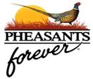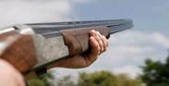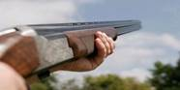

Pheasant & Quail Forever Central Indiana Chapter #642

Sporting Clay Fundraiser

at the Indiana Gun Club

**Saturday August 17th, 2024 Morning Flight Only**

Registration - 7:30am–8:30am;  Shotgun Start – 9:00am;  Lunch/Activities – 12:00–2:00pm



Please join us and our partners

“Reel Women Reel Men”

In Helping our Youth and Habitat – all you have to do is shoot!!

*Features for* ***Everyone***

|  |  |  |
| --- | --- | --- |
| * ***Teams of 5 Persons*** * 100 Shot Round * Vendor Booths * **PF Membership** * *Lowest* Score Prize | * Lunch * Refreshments * Prizes * Individual Winners * Mulligans (sure hits!) | * Private Gun Auction * Flurry Station * Silent Auction * Raffle/Games * Team Winners |

**Registration & Sponsorships**

**Teams of 5 Shooters** *(will take precedent over individuals)***-  $750.00**

**Individual Shooter  -  $150.00**

**PF Friends Sponsorship- $25 minimum (and/or prize donation)**

**Bobwhite Sponsorship- $100.00**

**Ringneck Sponsorship- $200.00**

**Station Sponsorship - $300.00**

**Lunch Sponsorship  -  $400.00**

**Rooster Booster Sponsorship - $800.00**

**Title Sponsorship - $1,000.00**

|  |
| --- |
| **To sponsor, register, or ask questions, please call or email:**  **Amanda Atkinson**, 219-805-2380, [adreger17@gmail.com](mailto:adreger17@gmail.com) |